WHAT TO SEE IN PILSEN DURING YOUR VISIT

“A NIGHT WITH OPERA“
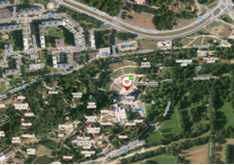
Ending the theatre season with an opera under the open sky has been a tradition of the Josef Kajetán Tyl Theatre since 2015. The goal if the event is to present operas in their full monumentality and offer an extraordinary experience in the natural amphitheatre setting. The project annually attracts thousands of viewers, not only opera enthusiasts but also those who have not encountered opera before and prefer the informal atmosphere over a traditional theater visit. For the conclusion of the 2023/2024 season, we are once again preparing two performances – an opera and a musical. You can look forward to the festive opera "Libuše" by Bedřich Smetana, written for the opening of the National Theatre.
- When: 28. June 2024 – 20:30 hod (8:30 PM)
- Place: Amfiteátr Lochotín Plzeň
- Address: Pod Vinicemi 928/6, 301 00 Plzeň 1
- Tickets: not yet being sold (https://nocsoperou.cz)

TECHMANIA SCIENCE CENTER
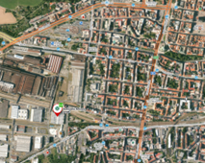
Science shows, puzzles, experiments, classic and interactive exhibitions, unexpected experiments, unusual workshops and a super-modern planetarium. All this is offered by the Techmania Science Centre in Pilsen, which will convince the whole family in all weathers.
- Address: U Planetária 2969/1, 301 00 Plzeň
- Opening hours: Tuesday - Friday: 8:30 AM- 5 PM and Saturday and Sunday : 10:00 -18:00
- Tickets: 280 CZK
- Techmania Science Center

ZOO PILSEN, BOTANIC GARDEN AND DINOPARK
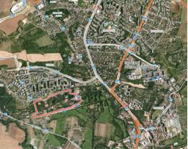
The Zoological and Botanical Garden of Pilsen is a zoological and botanical garden in Pilsen, the second oldest zoo in the Czech Republic. It breeds the most species of animals of any zoo in the Czech Republic and DinoPark Pilsen is an amusement and educational park in Pilsen.
- Address: Pod Vinicemi, 301 00, Plzeň
- Opening hours: daily - 8 AM - 6 PM
- Tickets: 160 - 390 CZK (it is possible to buy ticket only for zoo or Dinopark (but the entrance for Dinopark is from street Pod Vinicemi)
- https://zooplzen.cz

PILSNER URQUELL BREWERY TOUR
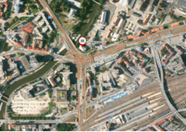
The Pilsner Urquell brewery offers tours, which will impress beer fans and history lovers. You will view the original locations where the famous Pilsner Urquell beer was born 180 years ago, and whose story continues even today. The culmination of the tour is a tasting of unfiltered Pilsner Urquell beer in the historical cellars.
- Address: U Prazdroje 64/7, 301 00 Plzeň
- Tour times: 9 AM - 6 PM
- Tickets: 380 CZK
- Available languages: CZ,EN,DE
- www.prazdrojvisit.cz/en/tours/pilsner-urquell-brewery-tour/

PILSEN HISTORICAL UNDERGROUND
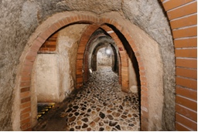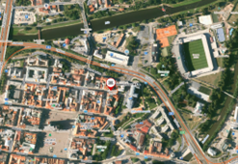
During the tour you will get to see life below the town and uncover the secrets of authentic finds and nooks and crannies that are hidden underground. You will find out how the underground originated, and see for yourself in how many different ways it was utilised.
- Address: Veleslavínova 58/6, 301 00 Plzeň 3-Vnitřní Město
- Opening hours: daily 10 AM – 6 PM
- Tickets: 190 CZK
- Available languages: CZ,EN,DE
- www.prazdrojvisit.cz/en/tours/pilsner-urquell-brewery-tour/

ST. BARTHOLOMEW’S CATHEDRAL
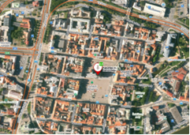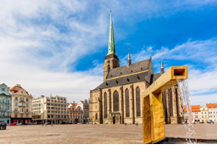
The Gothic three-aisled cathedral stands on the Republic Square in Pilsen. The cathedral was probably founded together with the city around 1295. The cathedral is dominated by a tower, which you can climb and from which you have a wonderful view of the city and the surrounding area.
- Opening hours: Weekdays 10 AM - 6 PM, weekends and holidays 13:00-18:00
- Tickets: Free tours (free)
- www.bip.cz/en/katedrala-sv-bartolomeje
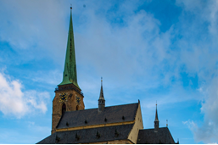
PILSEN TOWER

- Opening hours: daily from 10 AM - 6:30 PM, the last entry at 6:00pm
- Tickets: Full admission 60 - 90 CZK

Náměstí republiky (Republic Square)
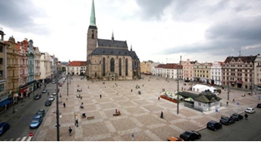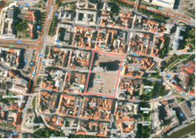
Square of the Republic is adorned with ornate townhouses and the Pilsen Town Hall. One of these buildings hosts the Museum of Puppets, boasting an extensive collection of puppets spread across three floors.
Within the square, you’ll encounter the Golden Fountains, representing a gargoyle, a camel and an angel, symbols also featured in the Pilsen coat of arms.

Muzeum loutek (Museum of Puppets)
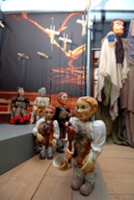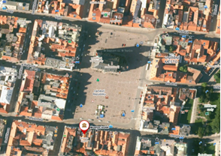

- Address: náměstí Republiky 23, 301 00 Plzeň
- Opening hours: Tuesday - Sunday 10 AM - 6 PM
- Tickets: 30 - 60 CZK
- https://muzeum-loutek.cz/en/

MLÝNSKÁ STROUHA PARK
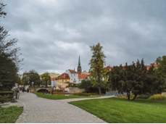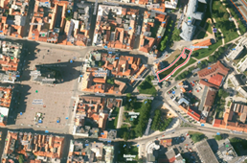
It is a relaxation area just outside the centre, where you can sit by the water and walk around the colourful sculptures.

BIG SYNAGOGUE
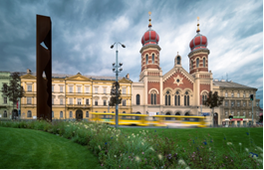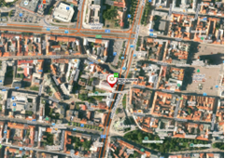
- It is the largest synagogue in the Czech Republic and the third largest synagogue in the world after the synagogues in Jerusalem and Budapest.
- Tickets: 80-120 CZK
- Opening hours: Sunday - Thursday 10 AM - 5 PM
- Address: sady Pětatřicátníků 11, 301 00 Plzeň

